Lab - Using Wireshark to View Network Traffic
Topology
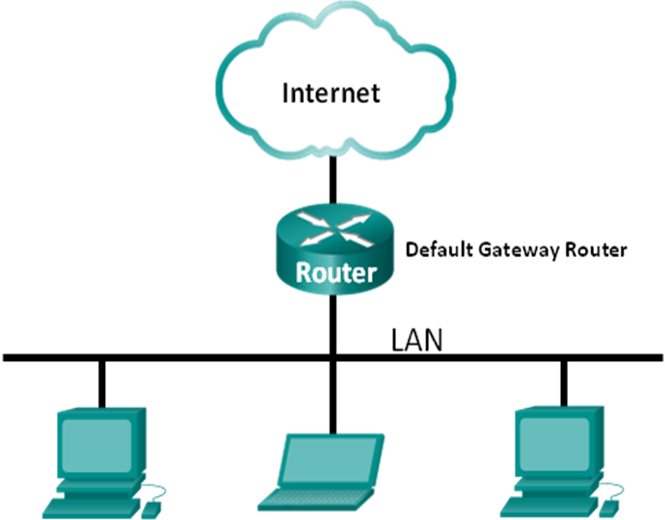
Objectives
Part 1: Capture and Analyze Local ICMP Data in Wireshark
Part 2: Capture and Analyze Remote ICMP Data in Wireshark
Background / Scenario
Wireshark is a software protocol analyzer, or "packet sniffer" application, used for network troubleshooting, analysis, software and protocol development, and education. As data streams travel back and forth over the network, the sniffer "captures" each protocol data unit (PDU) and can decode and analyze its content according to the appropriate RFC or other specifications.
Wireshark is a useful tool for anyone working with networks and can be used with most labs in the CCNA courses for data analysis and troubleshooting. In this lab, you will use Wireshark to capture ICMP data packet IP addresses and Ethernet frame MAC addresses.
Required Resources
- 1 PC (Windows 7 or 8 with Internet access)
- Additional PC(s) on a local-area network (LAN) will be used to reply to ping requests.
- Capture and Analyze Local ICMP Data in Wireshark
In Part 1 of this lab, you will ping another PC on the LAN and capture ICMP requests and replies in Wireshark. You will also look inside the frames captured for specific information. This analysis should help to clarify how packet headers are used to transport data to their destination.
  - Retrieve your PC’s interface addresses.
For this lab, you will need to retrieve your PC’s IP address and its network interface card (NIC) physical address, also called the MAC address.
    - Open a command window, type ipconfig /all, and then press Enter.
    - Note your PC interface’s IP address and MAC (physical) address.
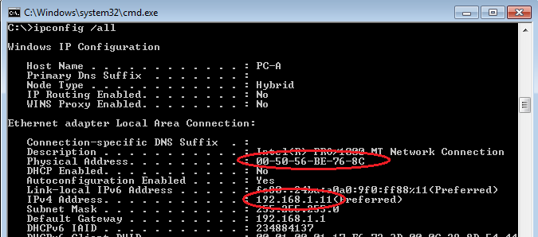
    - Ask a team member for their PC’s IP address and provide your PC’s IP address to them. Do not provide them with your MAC address at this time.
  - Start Wireshark and begin capturing data.
    - On your PC, click the Windows Start button to see Wireshark listed as one of the programs on the pop-up menu. Double-click Wireshark.
    - After Wireshark starts, click Interface List.
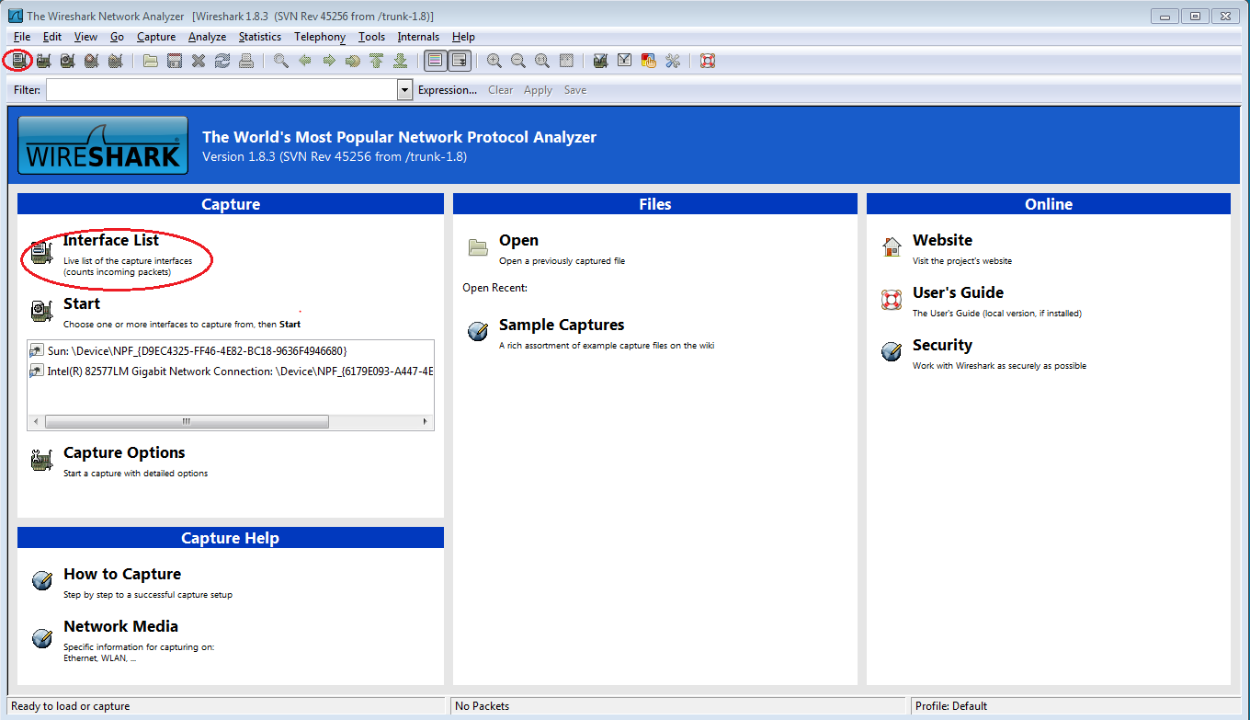
Note: Clicking the first interface icon in the row of icons also opens the Interface List.
    - On the Wireshark: Capture Interfaces window, click the check box next to the interface connected to your LAN.
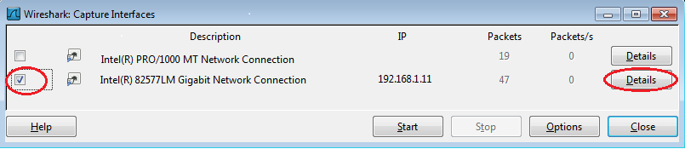
Note: If multiple interfaces are listed and you are unsure which interface to check, click the Details button, and then click the 802.3 (Ethernet) tab. Verify that the MAC address matches what you noted in Step 1b. Close the Interface Details window after verifying the correct interface.
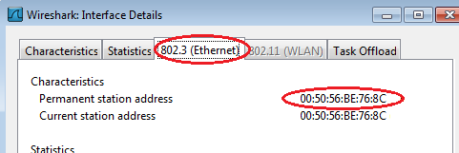
    - After you have checked the correct interface, click Start to start the data capture.
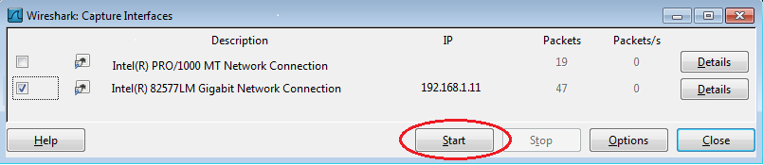

Information will start scrolling down the top section in Wireshark. The data lines will appear in different colors based on protocol.
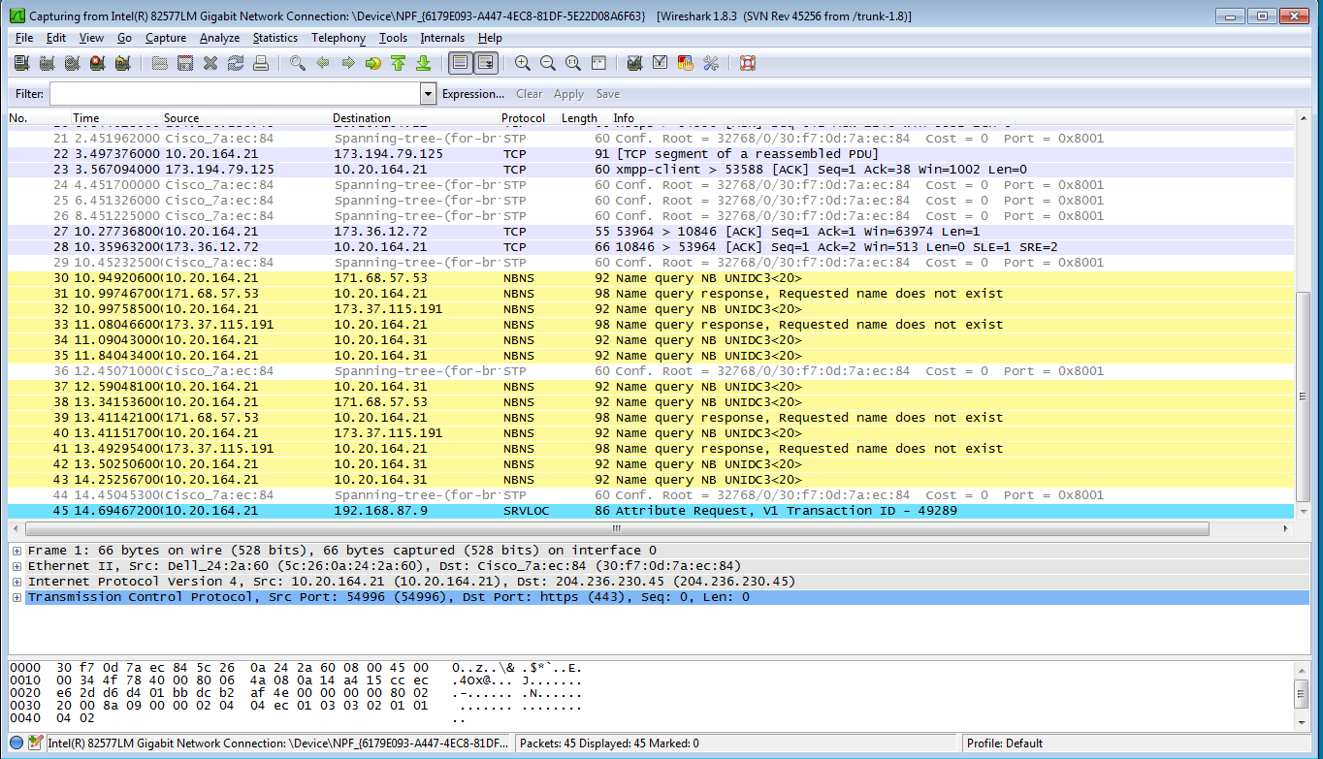
    - This information can scroll by very quickly depending on what communication is taking place between your PC and the LAN. We can apply a filter to make it easier to view and work with the data that is being captured by Wireshark. For this lab, we are only interested in displaying ICMP (ping) PDUs. Type icmp in the Filter box at the top of Wireshark and press Enter or click on the Apply button to view only ICMP (ping) PDUs.
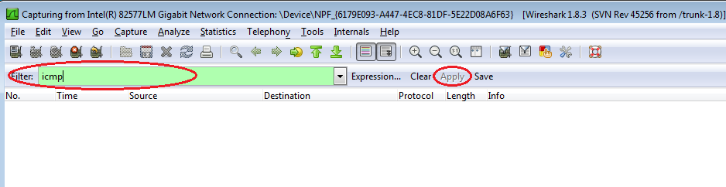

    - This filter causes all data in the top window to disappear, but you are still capturing the traffic on the interface. Bring up the command prompt window that you opened earlier and ping the IP address that you received from your team member. Notice that you start seeing data appear in the top window of Wireshark again.
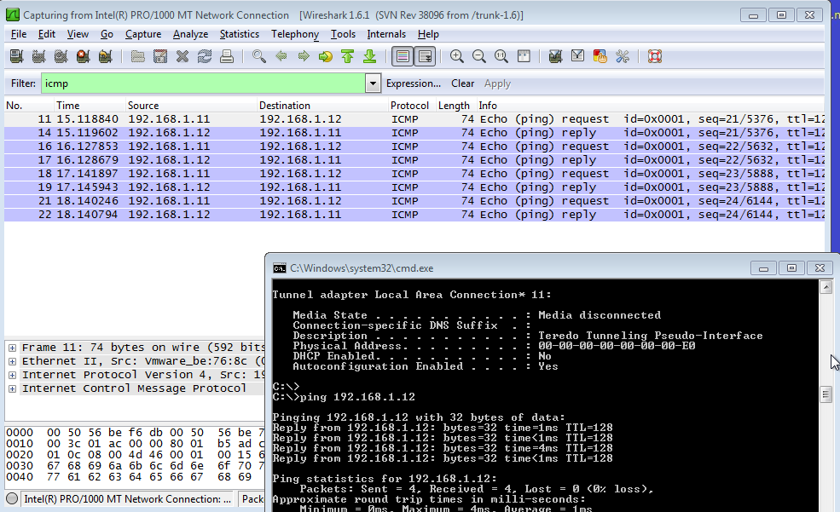
Note: If your team member’s PC does not reply to your pings, this may be because their PC firewall is blocking these requests. Please see Appendix A: Allowing ICMP Traffic Through a Firewall for information on how to allow ICMP traffic through the firewall using Windows 7.
    - Stop capturing data by clicking the Stop Capture icon.
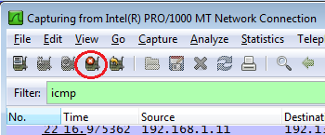

  - Examine the captured data.
In Step 3, examine the data that was generated by the ping requests of your team member’s PC. Wireshark data is displayed in three sections: 1) The top section displays the list of PDU frames captured with a summary of the IP packet information listed, 2) the middle section lists PDU information for the frame selected in the top part of the screen and separates a captured PDU frame by its protocol layers, and 3) the bottom section displays the raw data of each layer. The raw data is displayed in both hexadecimal and decimal form.
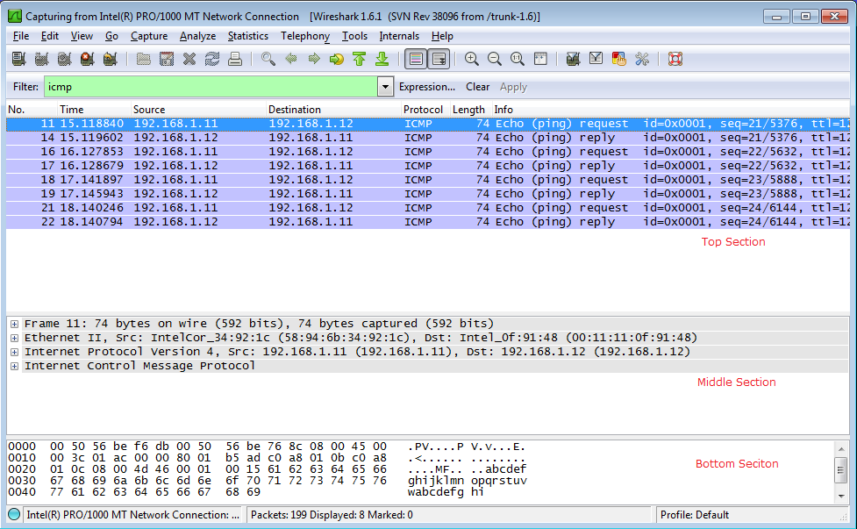
    - Click the first ICMP request PDU frames in the top section of Wireshark. Notice that the Source column has your PC’s IP address, and the Destination contains the IP address of the teammate’s PC you pinged.
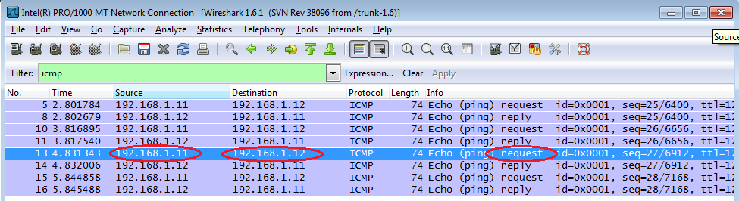

    - With this PDU frame still selected in the top section, navigate to the middle section. Click the plus sign to the left of the Ethernet II row to view the Destination and Source MAC addresses.
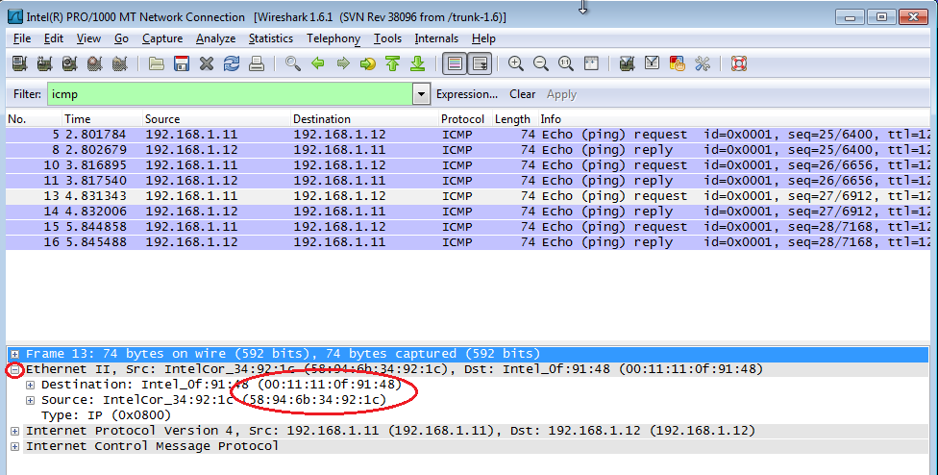
Does the Source MAC address match your PC’s interface? ______
Does the Destination MAC address in Wireshark match your team member’s MAC address?
_____
How is the MAC address of the pinged PC obtained by your PC?
___________________________________________________________________________________
Note: In the preceding example of a captured ICMP request, ICMP data is encapsulated inside an IPv4 packet PDU (IPv4 header) which is then encapsulated in an Ethernet II frame PDU (Ethernet II header) for transmission on the LAN.
- Capture and Analyze Remote ICMP Data in Wireshark
In Part 2, you will ping remote hosts (hosts not on the LAN) and examine the generated data from those pings. You will then determine what is different about this data from the data examined in Part 1.
  - Start capturing data on the interface.
    - Click the Interface List icon to bring up the list PC interfaces again.
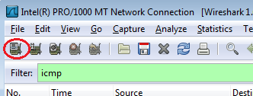

    - Make sure the check box next to the LAN interface is checked, and click Start.
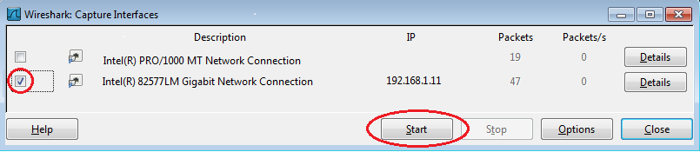
    - A window prompts to save the previously captured data before starting another capture. It is not necessary to save this data. Click Continue without Saving.
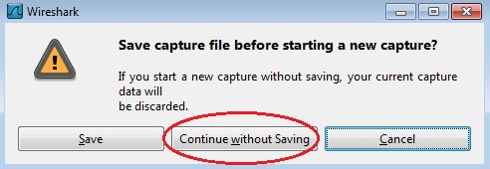
    - With the capture active, ping the following three website URLs:
      - www.yahoo.com
      - www.cisco.com
      - www.google.com
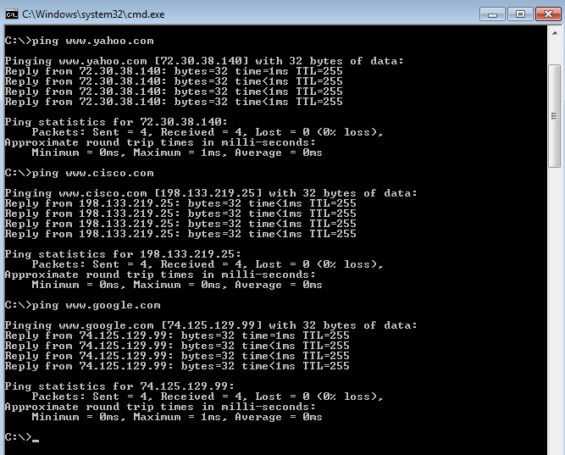
Note: When you ping the URLs listed, notice that the Domain Name Server (DNS) translates the URL to an IP address. Note the IP address received for each URL.
    - You can stop capturing data by clicking the Stop Capture icon.

  - Examining and analyzing the data from the remote hosts.
    - Review the captured data in Wireshark, examine the IP and MAC addresses of the three locations that you pinged. List the destination IP and MAC addresses for all three locations in the space provided.
1st Location: IP: _____._____._____._____ MAC: ____:____:____:____:____:____
2nd Location: IP: _____._____._____._____ MAC: ____:____:____:____:____:____
3rd Location: IP: _____._____._____._____ MAC: ____:____:____:____:____:____
    - What is significant about this information?
____________________________________________________________________________________
    - How does this information differ from the local ping information you received in Part 1?
____________________________________________________________________________________
____________________________________________________________________________________
Reflection
Why does Wireshark show the actual MAC address of the local hosts, but not the actual MAC address for the remote hosts?
_______________________________________________________________________________________
_______________________________________________________________________________________
Appendix A: Allowing ICMP Traffic Through a Firewall
If the members of your team are unable to ping your PC, the firewall may be blocking those requests. This appendix describes how to create a rule in the firewall to allow ping requests. It also describes how to disable the new ICMP rule after you have completed the lab.

  - Create a new inbound rule allowing ICMP traffic through the firewall.
    - From the Control Panel, click the System and Security option.
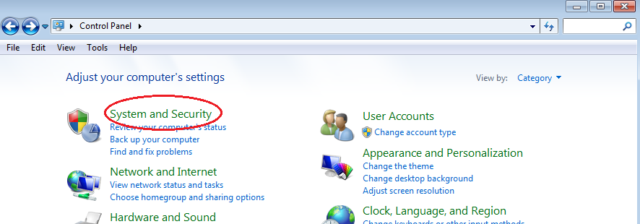
    - From the System and Security window, click Windows Firewall.
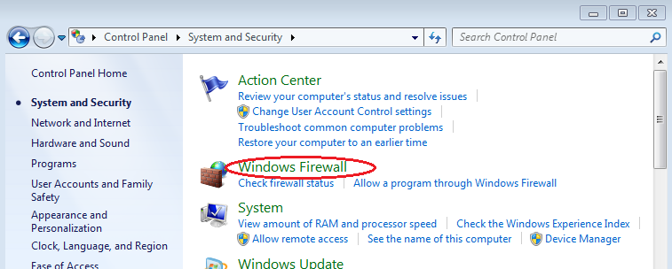
    - In the left pane of the Windows Firewall window, click Advanced settings.
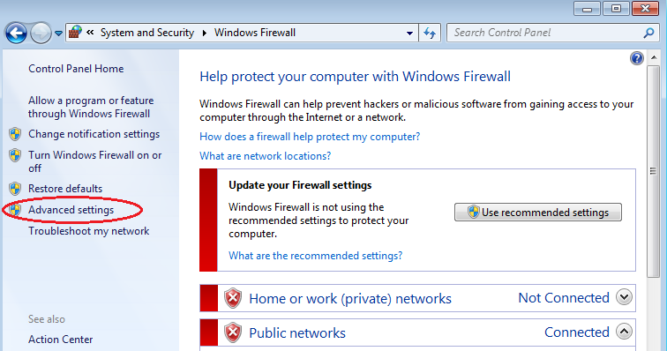
    - On the Advanced Security window, choose the Inbound Rules option on the left sidebar and then click New Rule… on the right sidebar.
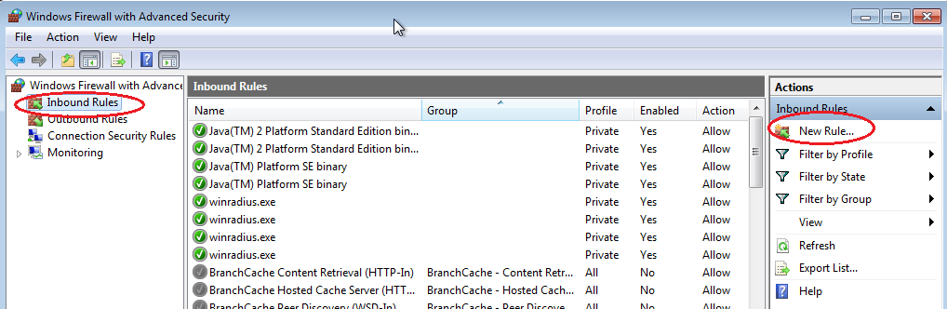
    - This launches the New Inbound Rule wizard. On the Rule Type screen, click the Custom radio button and click Next
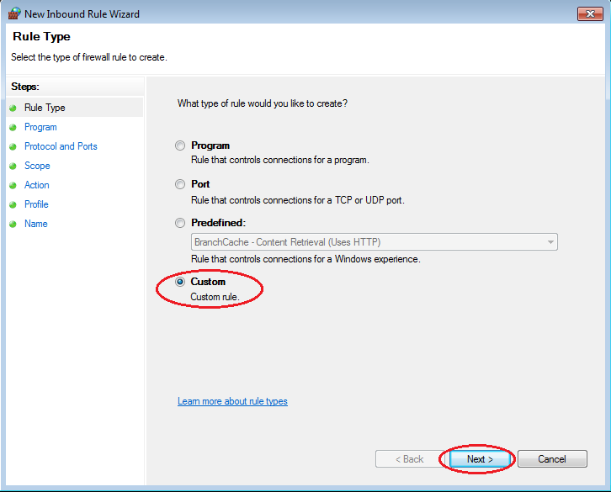

    - In the left pane, click the Protocol and Ports option and using the Protocol type drop-down menu, select ICMPv4, and then click Next.
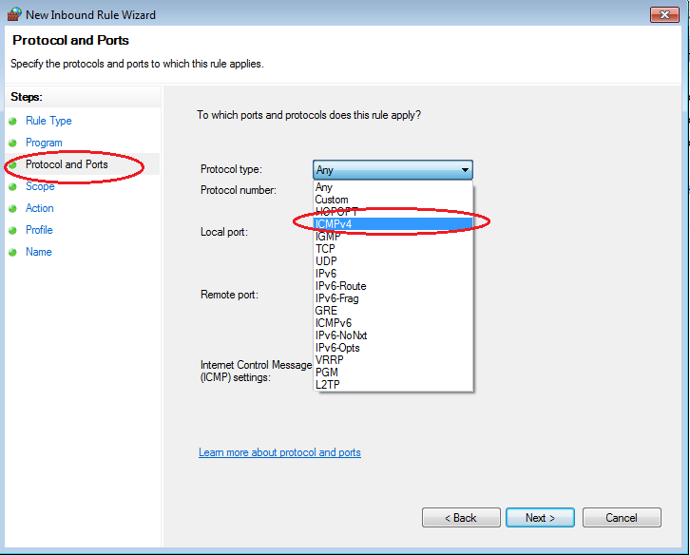
    - In the left pane, click the Name option and in the Name field, type Allow ICMP Requests. Click Finish.
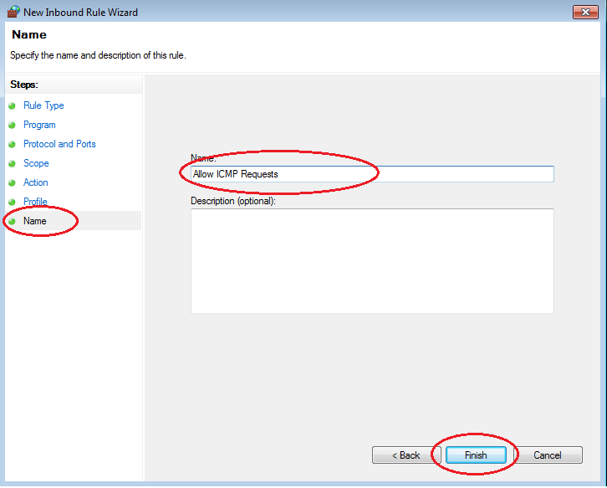
This new rule should allow your team members to receive ping replies from your PC.
  - Disabling or deleting the new ICMP rule.
After the lab is complete, you may want to disable or even delete the new rule you created in Step 1. Using the Disable Rule option allows you to enable the rule again at a later date. Deleting the rule permanently deletes it from the list of Inbound Rules.
    - On the Advanced Security window, click Inbound Rules in the left pane and then locate the rule you created in Step 1.
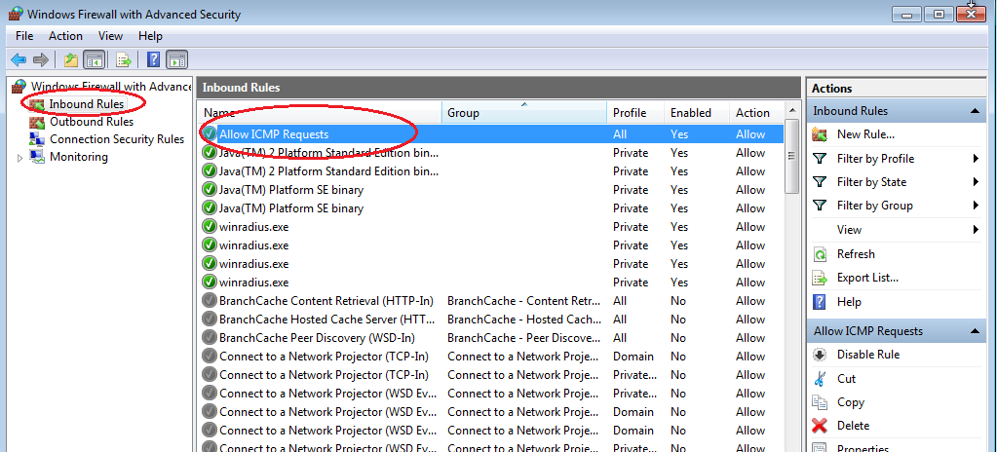
    - To disable the rule, click the Disable Rule option. When you choose this option, you will see this option change to Enable Rule. You can toggle back and forth between Disable Rule and Enable Rule; the status of the rule also shows in the Enabled column of the Inbound Rules list.
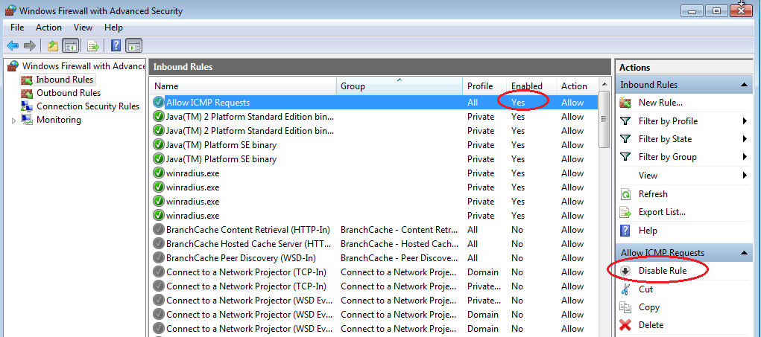

    - To permanently delete the ICMP rule, click Delete. If you choose this option, you must re-create the rule again to allow ICMP replies.
